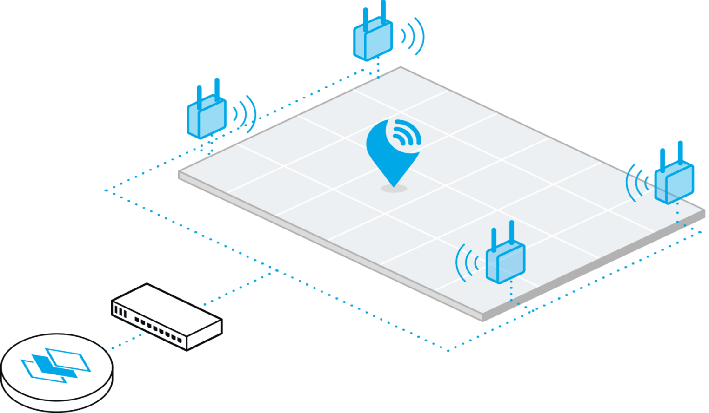

**Ultra-wideband precision test**

Report of the Project DCRC at minor Adaptive robotics, Fontys engineering

Author : Joost van Wolfswinkel, Max Jans

Student number : 3497941, 3497046

Minor : Adaptive Robotics

Project : Decentralized Cross Robot Control

Teacher : Sjriek Alers

Date : 25/06/2021  
Version : 0002

General information

**Project:**

Project name : Decentralized Robot Control Safety features   
Part of : Minor Adaptive Robotics, DCRC, Fontys Engineering

**Information student:**

Name : Joost van Wolfswinkel

Study : Fontys Engineering Mechatronics

Student number : 3497941

Email : j.vanwolfswinkel@student.fontys.nl

**Information student:**

Name : Max Jans

Study : Fontys Engineering Mechatronics

Student number : 3497046

Email : max.jans@student.fontys.nl

Version management

Please update this table when changing or adding something to this report.

|  |  |  |  |
| --- | --- | --- | --- |
| Version | Date | Name | Description |
| 0001 | 25/06/2021 | Joost van Wolfswinkel | First draft |
| 0002 | 02/07/2021 | Joost van Wolfswinkel | Added feedback |
|  |  |  |  |
|  |  |  |  |
|  |  |  |  |
|  |  |  |  |
|  |  |  |  |

Index

List of figures 3

List of tables 3

1. Introduction 4

2. Assignment overview 5

3. X and Y measuring 6

3.1. X and Y Results 6

3.2. Setup and execution 10

4. Influence of Z on X and Y 11

4.1. Influence of Z results 11

4.2. Setup and execution 12

5. Conclusion & recommendation 13

6. Attachments 0

I. Attachment X and Y measurement data 0

II. Attachment X Y Z measurement data 4

# List of figures

Figure 1: Robot with CoLAB 4

Figure 2: Test location X and Y 5

Figure 3: UWB signal strenght 9

Figure 4: Anchors and measure positions X Y 10

Figure 5: Anchor Figure 6: Measure position 10

Figure 7: Anchors and measure positions X Y Z Figure 8: Different positions in height 12

# List of tables

Table 1: Deviation overview graph X Y 6

Table 2: Highest deviations 7

Table 3: Standard deviation graph 7

Table 4: Deviation overview positions 8

Table 5: Avarage deviation positions 8

Table 6: Anchors and measure positions X Y 10

Table 7: Deviation overview graph X Y Z 11

# Introduction

This report is written to document the sensor assignment for the ‘Decentralized Cross Robot Control’ project, also called DCRC, of the minor adaptive robotics. The goal of the DCRC project is to develop a device that is called ‘CoLAB’. The CoLAB should be a box that is capable of connecting to every autonomous driving robot and give and take information from them. With that information the CoLAB is used to tell the robot where to go and what to do. The CoLAB is also capable to communicate in a bigger network of other CoLAB’s, to divide information and tasks given by a main server.

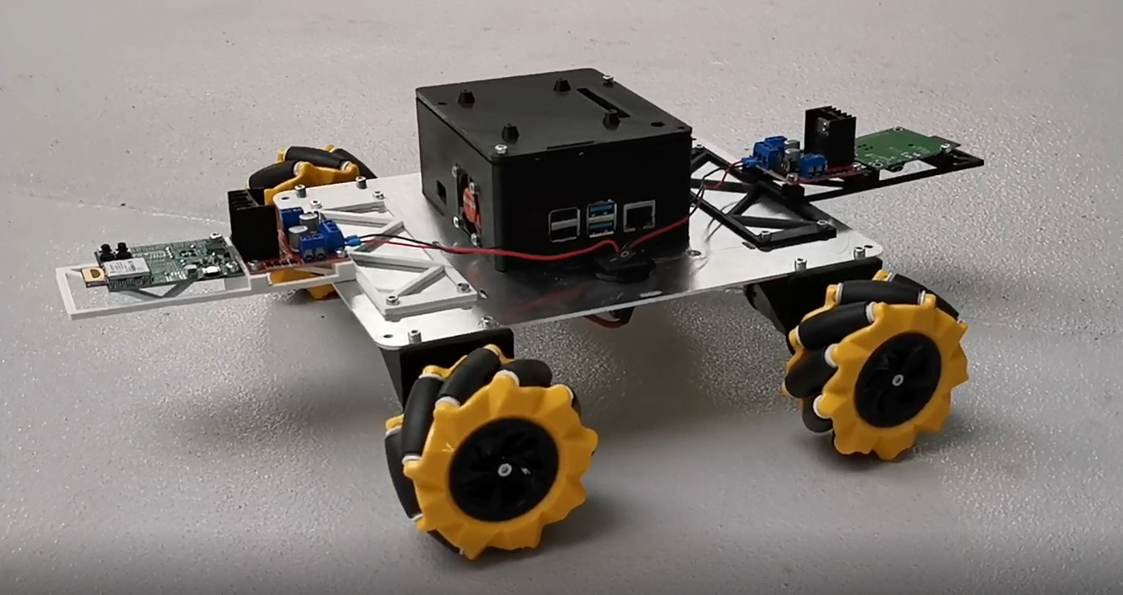

Figure 1: Robot with CoLAB

The CoLAB works together with an ultra-wideband system. The ultra-wideband or UWB is used to find the location and the orientation of the CoLAB. This is done with two tags on the front and the back of the robot, and a couple of anchors on the wall of the building. The anchors measure the distance between the tag and themselves. The distance to every anchor is then used to compute the location of the tag. With both locations of the front and back tag the location and orientation of the CoLAB can be found.

The problem of this setup is that the UWB sensors are not always precise. That is why this report with UWB test is written. At first there will be an assignment overview for these test (2). This will be followed with 2 tests. The first test will look into the precision of different setups to measure X and Y coordinates (3). And the second test will look into the influence of the Z coordinate on the X and Y coordinates (4).

# Assignment overview

The goal of this test is to find out how precise the UWB’s are in different setups. The UWB’s will measure 9 positions in the field 5 times. This will give us 45 measurements per setup. The setups will be:

* 6 anchors at a height of 3 meters.
* 6 anchors at a height of 2 meters.
* 4 anchors at a height of 3 meters.
* 4 anchors at a height of 2 meters.

The measurement will be in the place on the picture below. This place has 6 places where anchors can be mounted and there are no obstructions in this area. The anchors and positions will be measured with a laser sensor to provide high accuracy of placement. The Tag that the sensors have to locate will be placed on the ground. This tag will be given a X, Y and Z by the anchors. Because the Z value is not used in this project, the focus will be on the precision of the X and Y position.

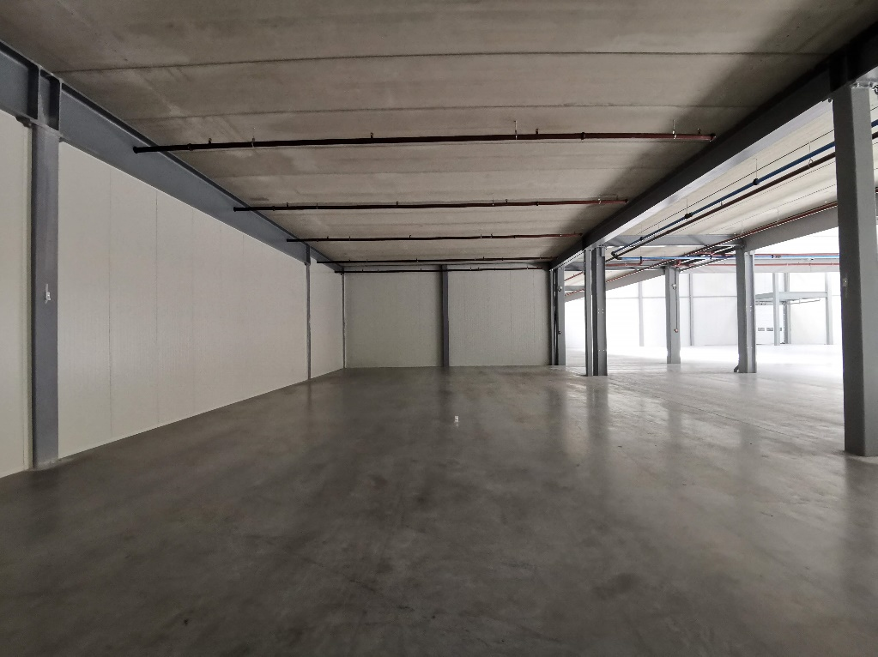

Figure 2: Test location X and Y

The deliverables are:

* Measurement data
  + 1 tag
  + 9 different positions measured 5 times per setup
  + 4 different setups
* Calculation of precision, visualized with a deviation graph.
* well-founded conclusion of the best setup

# X and Y measuring

This chapter will explain the results of the UWB X and Y precision test. This will be followed up with the setup and the execution of this measurement.

## X and Y Results

For the base of the results the measurement data of attachment I is used. The measurement data of all positions and setups is converted in the following graph (Table 1: Deviation overview graph X Y). In this graph the standard deviation of the X and Y of every position in every setup is visualized. Every X and Y has a maximum and a minimum standard deviation. This standard deviation can be calculated with the following formula:

Some explanations of this graph:

* If the deviation is low, then that means that the precision will be high.
* If the purple bar is long that means that the precision changes a lot in different positions.
* If the purple bar is short then the precision is constant and doesn’t chance at every point.

Table 1: Deviation overview graph X Y

In the graph we can directly see that the precision of 6 anchors at 3m (6-3m) is very high and constant. Strangely the Y axes in 6-2m and 4-3m is worse than the 4-2m. There is no conclusion why this is the case, But it’s clear that at 6-3m the positions become way more precise.

To get a better look, the worst cases are put in a standard deviation graph (Table 3: Standard deviation graph). This will give the maximum distance a measurement can deviate from the original position per setup.

Table 2: Highest deviations

|  |  |
| --- | --- |
| Setup | Highest deviation |
| 4-2m | 0,08264 m |
| 6-2m | 0,08877 m |
| 4-3m | 0,10431 m |
| 6-3m | 0,03012 m |

Table 3: Standard deviation graph

This graph shows that the deviation of 6-3m is way smaller and taller than all the other setups. Which means there is less change of a higher deviation. To be precise the worst deviation of the 6-3m is 5cm and has a low frequency of happening.

The deviation overview is also done for every position, in the hope to get more info about a good setup. The team expected a better result in the middle position. This is because it is in a close range to all the sensors. In the corners a worse value was expected because some anchors will have a longer distance to the tag, this can disturb the measurement. Visible in the graph below is that the middle position number 5 is indeed very low. But some of the corners (1, 3, 7 and 9) are better than expected. Why this is isn’t sure. Even looking to the average value’s of this graph will give the same results, see graph below.

Table : Deviation overview positions

Table : Avarage deviation positions

Another way to find more information about why the graph looked like it did is looking at the weak spots of the UWB anchor’s signals. Visible in the picture below is the strength of the signal of the UWB (light blue line). The direct signals to position 6 is visualized with the green stripes. This shows that almost all anchors should be at high strength. Somehow positions 6 is still one of the worst positions. So it is not possible to get a conclusion from the available data.

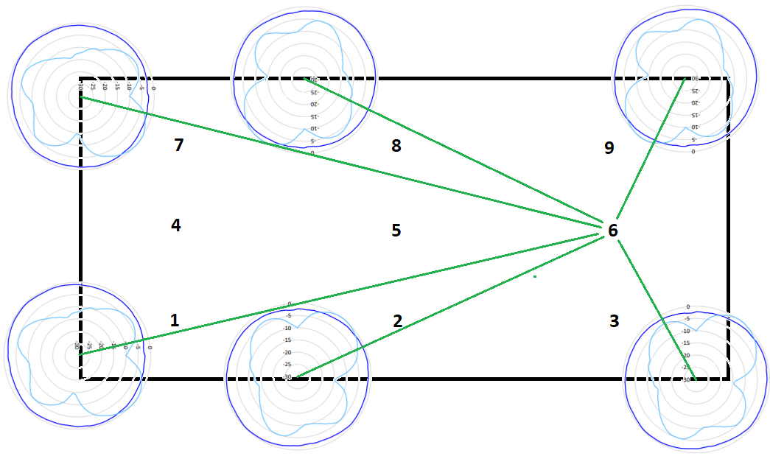

Figure : UWB signal strenght

## Setup and execution

The setup was made next to the Fontys on the Brainport Industry Campus in Eindhoven. For the place of the setup there were a couple of important points. At first the setup needs 6 places where anchors could be easily mounded on different heights, The setup had to be clear of obstructions, and the positions of the anchors shouldn’t be too far or too close to each other. The locations of the anchors and measurement points where as followed:

Red: Position of anchors

Green: Points to measure (tag)

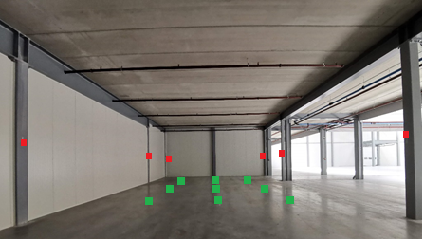

Figure 4: Anchors and measure positions X Y

Table 6: Anchors and measure positions X Y

|  |  |  |  |  |  |
| --- | --- | --- | --- | --- | --- |
| Layout measuring | | | | |  |
| Anchor(15,15:9,35) |  |  |  | Anchor(15,18:0) |  |
|  | point9(13:8) | point6(13:5) | point3(13:2) |  |  |
|  |  |  |  |  |  |
| *Anchor(5,45:9,35) | point8(7,5:8) | point5(7,5:5) | point2(7,5:2) | *Anchor(5,17:0) |  |
|  |  |  |  |  |  |
|  | point7(2:8) | point4(2:5) | point1(2:2) |  | ^ |
| Anchor(0:9,35) |  |  |  | Anchor(0:0) | X |
| * = Turned off when in use of 4 anchors | | | | < Y | 0 |

The anchors where mounted on the wall as the first picture below and the measure point was marked with tape like in the second picture. Both positions where measured with a distance laser for high accuracy. In the measurement the tag was moved from point to point. So that the anchors had to measure a different location every time. Every position was measured 5 times so that there would be more data to calculate with. In total for every setup there where 45 measurements.

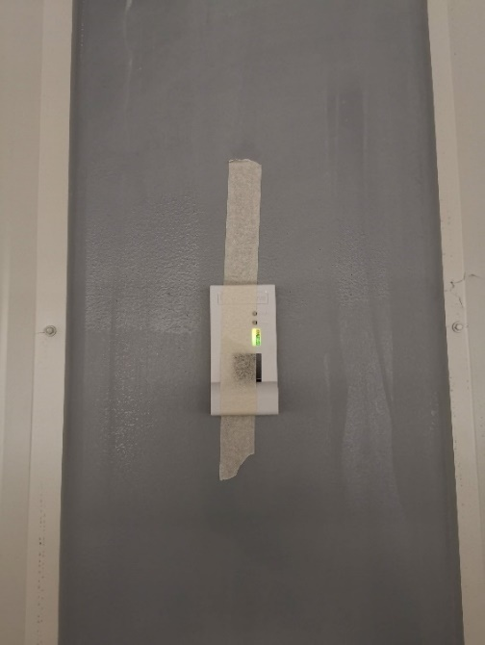 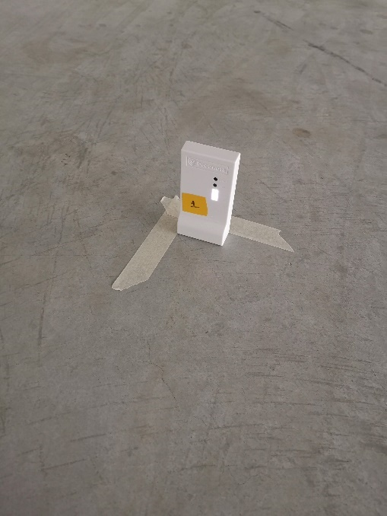

Figure 5: Anchor Figure 6: Measure position

# Influence of Z on X and Y

This chapter will describe the influence of Z on the X and Y value. This will be followed up with the setup and the execution of this measurement.

## Influence of Z results

What if the robot would move over a bump, there is a part of your floor that is a bit higher, or there are different heights of robots. To answer that question an extra test was done. This test looks into the influence of Z on the X and Y position. So if Z moves does the X position or the Y position then move as well? The following graph (Table 7: Deviation overview graph X Y Z) shows the standard deviation of this test. This graph is made out of the data in attachment II.

Table 7: Deviation overview graph X Y Z

Visible in the graph is that the Z has a low precision. Next to this, not visible in the graph, is the fact that the Z value was going up and down while measuring. This would sometimes variate between 0 and 1 meter. In this case we took the average of these values. The deviation is a lot, but made it very clear what kind of impacted it had on the X and Y values. The values of X and Y are a less precise than the first test, this is because when used a different setup, but these values where constant while Z was fluctuating. This tells us that There is no influence of Z in X and Y.

## Setup and execution

This setup used another order of placement for the anchors. This was chosen to see if data improves if 2 anchors are above each other. The anchors are placed on the same distance as they were in the previous test (5-6m). This is needed to prevent a change in the data because of the distance. Visible in the last paragraph 4.1 is that the X and Y are less precise than in the data of paragraph 3.1. This concludes that placing two anchors above each other will not make the measurement better. 2 pictures are placed below for a visualization of the test. The first picture shows to location of the setup with the locations of the tags and anchors. The second picture is a wooden plank that is used to tape the positions on different heights, those are the tag locations.

Red: Position of anchors

Green: Points to measure (tag)

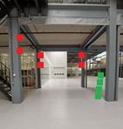 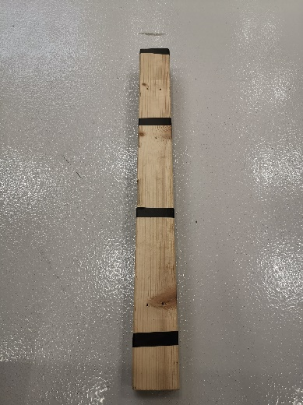

Figure 7: Anchors and measure positions X Y Z Figure 8: Different positions in height

# Conclusion & recommendation

Out of the data came the conclusion that 6 anchors at the height of 3m gives the most precision of the location of the tag. This setup had also a constant deviation for every measuring point. So It is needed to hang at least 6 anchors at a height of 3m and preferably with 5 to 10 meters away from each other. What position in the setup is better has not been concluded because of unconclusive data. In the second test it became visible that a bump in the road or a small different in height of your robot does not interfere with these X and Y values.

Because there is a big difference between 6 anchors at 3m and all the other setups, it is recommended to look further into higher numbers. What happens if there are more than 6 anchors, like a grid of 9. Or what happens if the anchors are mounted even higher. It is possible that these setups will provide even better precision.

# Attachments

## Attachment X and Y measurement data

4 anchors on a height of 2 meters

|  |  |  |  |  |  |  |  |  |  |  |
| --- | --- | --- | --- | --- | --- | --- | --- | --- | --- | --- |
| position | X.1 | Y.1 | X.2 | Y.2 | X.3 | Y.3 | X.4 | Y.4 | X.5 | Y.5 |
| 1 | 1,98 | 1,78 | 1,99 | 1,80 | 1,99 | 1,79 | 1,99 | 1,80 | 1,99 | 1,79 |
| 2 | 7,37 | 2,01 | 7,34 | 2,04 | 7,36 | 2,01 | 7,35 | 2,05 | 7,34 | 2,02 |
| 3 | 12,86 | 1,99 | 12,95 | 1,95 | 12,86 | 1,98 | 12,90 | 1,98 | 12,86 | 2,00 |
| 4 | 1,78 | 4,72 | 1,79 | 4,71 | 1,81 | 4,71 | 1,82 | 4,70 | 1,80 | 4,70 |
| 5 | 7,24 | 4,77 | 7,25 | 4,76 | 7,25 | 4,78 | 7,26 | 4,78 | 7,26 | 4,78 |
| 6 | 13,06 | 4,88 | 13,08 | 4,89 | 13,08 | 4,88 | 12,98 | 4,89 | 13,06 | 4,88 |
| 7 | 2,03 | 8,40 | 2,03 | 8,40 | 1,98 | 8,40 | 2,03 | 8,41 | 1,98 | 8,40 |
| 8 | 7,28 | 7,95 | 7,30 | 7,86 | 7,26 | 7,90 | 7,35 | 7,92 | 7,26 | 7,97 |
| 9 | 12,84 | 7,75 | 12,84 | 7,76 | 12,84 | 7,76 | 12,85 | 7,78 | 12,85 | 7,77 |

|  |  |  |  |  |  |  |
| --- | --- | --- | --- | --- | --- | --- |
| position | Goal X | Goal Y | Average X | Average Y | standard deviation X/Y | |
| 1 | 2,00 | 2,00 | 1,99 | 1,79 | 0,005367 | 0,012837 |
| 2 | 7,50 | 2,00 | 7,35 | 2,03 | 0,020513 | 0,033395 |
| 3 | 13,00 | 2,00 | 12,89 | 1,98 | 0,076021 | 0,036332 |
| 4 | 2,00 | 5,00 | 1,80 | 4,71 | 0,026077 | 0,012837 |
| 5 | 7,50 | 5,00 | 7,25 | 4,77 | 0,012837 | 0,017527 |
| 6 | 13,00 | 5,00 | 13,05 | 4,88 | 0,082637 | 0,010354 |
| 7 | 2,00 | 8,00 | 2,01 | 8,40 | 0,051769 | 0,008764 |
| 8 | 7,50 | 8,00 | 7,29 | 7,92 | 0,074297 | 0,081731 |
| 9 | 13,00 | 8,00 | 12,84 | 7,76 | 0,010354 | 0,019058 |

6 anchors on a height of 2 meters

|  |  |  |  |  |  |  |  |  |  |  |
| --- | --- | --- | --- | --- | --- | --- | --- | --- | --- | --- |
| position | X.1 | Y.1 | X.2 | Y.2 | X.3 | Y.3 | X.4 | Y.4 | X.5 | Y.5 |
| 1 | 1,97 | 1,95 | 1,93 | 1,78 | 1,98 | 1,78 | 1,90 | 1,79 | 1,91 | 1,80 |
| 2 | 7,51 | 1,86 | 7,49 | 1,91 | 7,47 | 1,90 | 7,46 | 1,91 | 7,47 | 1,90 |
| 3 | 13,01 | 1,98 | 12,92 | 1,97 | 12,97 | 1,99 | 12,97 | 1,96 | 13,02 | 1,98 |
| 4 | 2,02 | 4,83 | 2,00 | 4,83 | 1,98 | 4,85 | 2,02 | 4,86 | 2,02 | 4,86 |
| 5 | 7,51 | 4,85 | 7,48 | 4,87 | 7,48 | 4,85 | 7,47 | 4,84 | 7,45 | 4,84 |
| 6 | 12,87 | 4,86 | 12,88 | 4,88 | 12,90 | 4,88 | 12,90 | 4,88 | 12,90 | 4,88 |
| 7 | 1,90 | 7,99 | 1,87 | 8,00 | 1,87 | 8,01 | 1,90 | 8,02 | 1,87 | 8,04 |
| 8 | 7,22 | 7,66 | 7,26 | 7,80 | 7,20 | 7,80 | 7,20 | 7,80 | 7,21 | 7,80 |
| 9 | 12,95 | 7,73 | 12,95 | 7,76 | 12,97 | 7,74 | 12,96 | 7,75 | 12,98 | 7,78 |

|  |  |  |  |  |  |  |  |
| --- | --- | --- | --- | --- | --- | --- | --- |
| position | Goal X | Goal Y | Average X | | Average Y | standard deviation X/Y | |
| 1 | 2,00 | 2,00 | 1,94 | 1,82 | | 0,0653 | 0,0888 |
| 2 | 7,50 | 2,00 | 7,48 | 1,90 | | 0,0297 | 0,0261 |
| 3 | 13,00 | 2,00 | 12,98 | 1,98 | | 0,0739 | 0,0225 |
| 4 | 2,00 | 5,00 | 2,01 | 4,85 | | 0,0341 | 0,0267 |
| 5 | 7,50 | 5,00 | 7,48 | 4,85 | | 0,0326 | 0,0245 |
| 6 | 13,00 | 5,00 | 12,89 | 4,88 | | 0,0219 | 0,0107 |
| 7 | 2,00 | 8,00 | 1,88 | 8,01 | | 0,0286 | 0,0331 |
| 8 | 7,50 | 8,00 | 7,22 | 7,77 | | 0,0498 | 0,0751 |
| 9 | 13,00 | 8,00 | 12,96 | 7,75 | | 0,0238 | 0,0331 |

4 anchors on a height of 3 meters

|  |  |  |  |  |  |  |  |  |  |  |
| --- | --- | --- | --- | --- | --- | --- | --- | --- | --- | --- |
| position | X.1 | Y.1 | X.2 | Y.2 | X.3 | Y.3 | X.4 | Y.4 | X.5 | Y.5 |
| 1 | 1,93 | 1,81 | 1,98 | 1,83 | 1,96 | 1,85 | 1,95 | 1,84 | 1,87 | 1,83 |
| 2 | 7,36 | 1,74 | 7,36 | 1,82 | 7,38 | 1,85 | 7,37 | 1,83 | 7,44 | 1,78 |
| 3 | 12,80 | 2,04 | 12,78 | 2,11 | 12,82 | 2,08 | 12,80 | 2,09 | 12,79 | 2,11 |
| 4 | 1,71 | 4,78 | 1,68 | 4,80 | 1,68 | 4,81 | 1,68 | 4,81 | 1,67 | 4,81 |
| 5 | 7,39 | 4,68 | 7,41 | 4,67 | 7,39 | 4,67 | 7,40 | 4,68 | 7,38 | 4,66 |
| 6 | 13,00 | 4,75 | 12,98 | 4,89 | 12,97 | 4,96 | 12,96 | 4,89 | 12,99 | 4,91 |
| 7 | 1,87 | 7,88 | 1,79 | 7,97 | 1,77 | 7,91 | 1,82 | 7,89 | 1,78 | 7,92 |
| 8 | 7,45 | 7,62 | 7,44 | 7,63 | 7,44 | 7,66 | 7,43 | 7,68 | 7,48 | 7,64 |
| 9 | 12,78 | 7,77 | 12,78 | 7,78 | 12,75 | 7,80 | 12,74 | 7,80 | 12,80 | 7,82 |

|  |  |  |  |  |  |  |
| --- | --- | --- | --- | --- | --- | --- |
| position | Goal X | Goal Y | Average X | Average Y | standard deviation X/Y | |
| 1 | 2,00 | 2,00 | 1,94 | 1,83 | 0,0838 | 0,0222 |
| 2 | 7,50 | 2,00 | 7,38 | 1,80 | 0,0640 | 0,0667 |
| 3 | 13,00 | 2,00 | 12,80 | 2,09 | 0,0296 | 0,0403 |
| 4 | 2,00 | 5,00 | 1,68 | 4,80 | 0,0195 | 0,0171 |
| 5 | 7,50 | 5,00 | 7,39 | 4,67 | 0,0225 | 0,0151 |
| 6 | 13,00 | 5,00 | 12,98 | 4,88 | 0,0261 | 0,1043 |
| 7 | 2,00 | 8,00 | 1,81 | 7,91 | 0,0569 | 0,0632 |
| 8 | 7,50 | 8,00 | 7,45 | 7,65 | 0,0384 | 0,0422 |
| 9 | 13,00 | 8,00 | 12,77 | 7,79 | 0,0482 | 0,0325 |

6 anchors on a height of 3 meters

|  |  |  |  |  |  |  |  |  |  |  |
| --- | --- | --- | --- | --- | --- | --- | --- | --- | --- | --- |
| position | X.1 | Y.1 | X.2 | Y.2 | X.3 | Y.3 | X.4 | Y.4 | X.5 | Y.5 |
| 1 | 1,87 | 1,84 | 1,88 | 1,85 | 1,88 | 1,85 | 1,89 | 1,82 | 1,91 | 1,82 |
| 2 | 7,45 | 2,05 | 7,45 | 2,01 | 7,45 | 2,02 | 7,45 | 2,03 | 7,45 | 2,03 |
| 3 | 12,64 | 2,09 | 12,64 | 2,10 | 12,64 | 2,10 | 12,63 | 2,10 | 12,65 | 2,12 |
| 4 | 1,93 | 4,80 | 1,96 | 4,81 | 1,95 | 4,80 | 1,96 | 4,79 | 1,98 | 4,80 |
| 5 | 7,42 | 4,83 | 7,45 | 4,84 | 7,45 | 4,85 | 7,45 | 4,84 | 7,43 | 4,83 |
| 6 | 12,90 | 4,86 | 12,87 | 4,86 | 12,88 | 4,88 | 12,88 | 4,89 | 12,88 | 4,87 |
| 7 | 1,94 | 7,88 | 1,95 | 7,87 | 1,95 | 7,88 | 1,96 | 7,89 | 1,96 | 7,90 |
| 8 | 7,45 | 7,69 | 7,44 | 7,70 | 7,45 | 7,71 | 7,45 | 7,70 | 7,45 | 7,71 |
| 9 | 12,94 | 7,75 | 12,92 | 7,74 | 12,95 | 7,76 | 12,94 | 7,76 | 12,93 | 7,76 |

|  |  |  |  |  |  |  |
| --- | --- | --- | --- | --- | --- | --- |
| position | Goal X | Goal Y | Average X | Average Y | standard deviation X/Y | |
| 1 | 2,00 | 2,00 | 1,89 | 1,84 | 0,0267 | 0,0301 |
| 2 | 7,50 | 2,00 | 7,45 | 2,03 | 0,0000 | 0,0222 |
| 3 | 13,00 | 2,00 | 12,64 | 2,10 | 0,0141 | 0,0191 |
| 4 | 2,00 | 5,00 | 1,96 | 4,82 | 0,0279 | 0,0434 |
| 5 | 7,50 | 5,00 | 7,44 | 4,83 | 0,0219 | 0,0279 |
| 6 | 13,00 | 5,00 | 12,88 | 4,86 | 0,0149 | 0,0296 |
| 7 | 2,00 | 8,00 | 1,95 | 7,88 | 0,0128 | 0,0225 |
| 8 | 7,50 | 8,00 | 7,45 | 7,70 | 0,0088 | 0,0128 |
| 9 | 13,00 | 8,00 | 12,94 | 7,75 | 0,0225 | 0,0175 |

## Attachment X Y Z measurement data

|  |  |  |  |  |  |  |  |  |  |  |  |  |  |  |  |
| --- | --- | --- | --- | --- | --- | --- | --- | --- | --- | --- | --- | --- | --- | --- | --- |
| Position | X1 | Y1 | Z1 | X2 | Y2 | Z2 | X3 | Y3 | Z3 | X4 | Y4 | Z4 | X5 | Y5 | Z5 |
| 1 | 4,15 | 4,29 | -0,2 | 4,4 | 4,35 | 0,31 | 4,47 | 4,13 | 0,45 | 4,38 | 4,07 | 0,25 | 4,37 | 4,1 | 0,34 |
| 2 | 4,24 | 3,85 | -0,08 | 4,22 | 3,89 | -0,05 | 4,21 | 3,9 | -0,02 | 4,23 | 3,88 | 0,23 | 4,18 | 4,06 | 0,23 |
| 3 | 4,33 | 3,86 | 0,12 | 4,32 | 4,05 | 0,02 | 4,33 | 3,96 | 0,02 | 4,24 | 4,07 | 0,46 | 4,24 | 4,07 | 0,45 |
| 4 | 4,52 | 3,96 | 1,15 | 4,42 | 4,1 | 0,2 | 4,39 | 3,93 | 0,1 | 4,32 | 4,12 | 0,61 | 4,27 | 4,12 | 0,5 |

|  |  |  |  |  |  |  |  |  |  |
| --- | --- | --- | --- | --- | --- | --- | --- | --- | --- |
| Position | Goal X | Goal Y | Goal Z | Average X | Average Y | Average Z | Standard deviation X/Y/Z | | |
| 1 | 4,23 | 4,08 | 0,55 | 4,216 | 4,188 | 0,23 | 0,158 | 0,231 | 0,323 |
| 2 | 4,30 | 4,18 | 0,75 | 4,292 | 3,916 | 0,062 | 0,041 | 0,154 | 0,282 |
| 3 | 4,36 | 4,28 | 0,96 | 4,354 | 4,002 | 0,214 | 0,089 | 0,132 | 0,440 |
| 4 | 4,40 | 4,36 | 1,17 | 4,384 | 4,046 | 0,512 | 0,149 | 0,170 | 0,599 |

## 